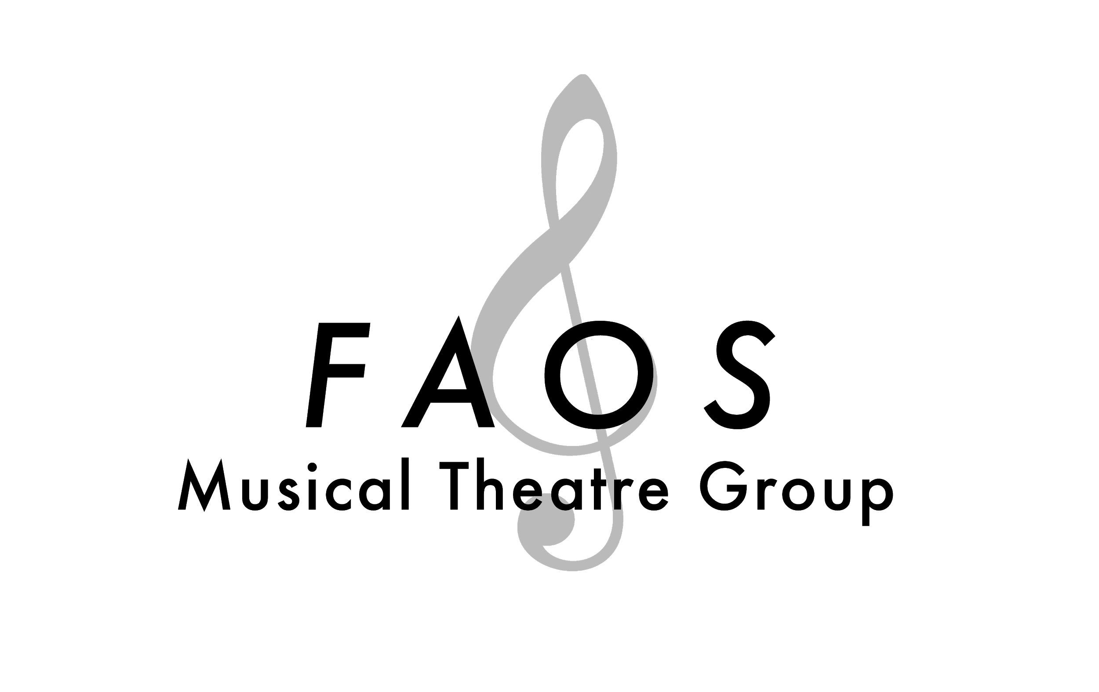
Name: Email: Mobile Number:

Landline Number: Height: Vocal Range:

Part(s) you wish to audition for:

Be in chorus if unsuccessful: Preferred audition date: Do you wish to be emailed the cast list:
⃞ Yes ⃞ No ⃞ Main ⃞ Alternative ⃞ Yes ⃞ No

Rehearsal dates you cannot attend:

Other shows you are committed to:

Previous shows/roles:

Audition Guidelines
If, during the audition, the auditionee is not portraying the character as perceived e.g. too aggressive, not aggressive enough, singing too quietly etc., the Director or Musical Director may stop the audition and ask them to continue in a different way, or ask them to repeat the audition. The Casting Committee will not be obliged to give a part to one of a number who audition, or a single auditionee if the Casting Committee feels them all unsuitable.
The results of casting a show following the main auditions will be delivered through the Website and also by Email at a designated time to those who supply an Email address at the time of submission.
Please complete the above form ideally no later than 7 days before the Audition date.
It would be appreciated that, if you cannot attend the Auditions, you advise the Secretary before Audition Day at secretary@faos.org.uk
Please note: There is an audition fee of £5 on the day for non-members (This is non-deductable from your subscription if successful).

